##### Logo Jacquard Crossbody Bag

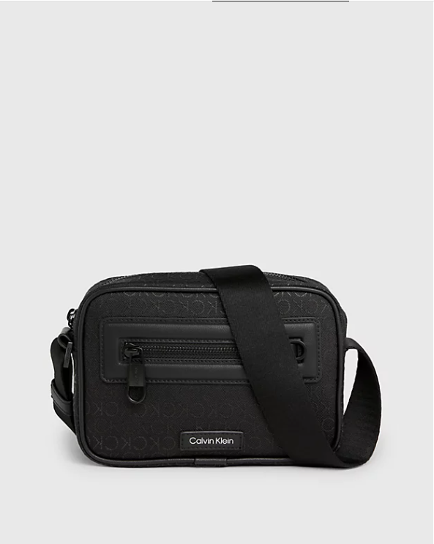  
A Logo Jacquard Crossbody Bag typically features a design where the brand's logo or initials are woven into the fabric of the bag, creating a distinctive pattern. This type of bag is often considered a signature piece for many luxury fashion brands, offering a combination of style and brand recognition.

If you're specifically looking for a Logo Jacquard Crossbody Bag in white, you might want to explore offerings from high-end fashion houses like Gucci, Louis Vuitton, or Burberry, as they often incorporate their iconic logos into their designs. These bags can range from classic and understated to bold and eye-catching, depending on the brand and their design aesthetic.

Additionally, you can also find Logo Jacquard Crossbody Bags from more affordable brands or fast-fashion retailers that offer similar styles at a lower price point. Just make sure to check the quality of the materials and craftsmanship to ensure you're getting a bag that meets your standards. Online fashion retailers and department stores are good places to start your search for a Logo Jacquard Crossbody Bag in black.